

redress procedure and request form
Materials International Postdoctoral Programme in Materials Science and Engineering
July 2025




Project: 101178250 — ATENEA — HORIZON-MSCA-2023-COFUND-01
Funded by the European Union. Views and opinions expressed are however those of the author(s) only and do not necessarily reflect those of the European Union or European Research Executive Agency (REA). Neither the European Union nor the granting authority can be held responsible for them.

Redress Procedure

1. Purpose
This procedure outlines the process by which applicants can seek redress regarding how their application was handled during the evaluation and eligibility-checking process. It ensures transparency, fairness, and a clear mechanism for resolving disputes.

2. Scope
This redress procedure applies to all candidates who have submitted an application and wish to challenge aspects of the evaluation process, specifically at Levels 1–3, including:
- Eligibility checking
- Evaluation outcomes
- Procedural fairness
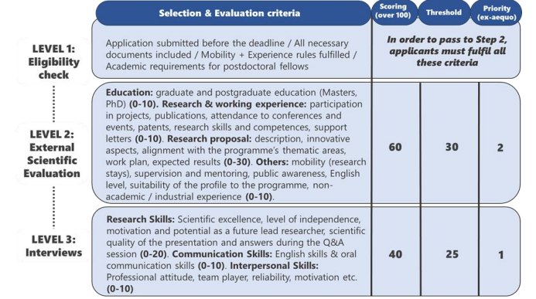
Figure 1. Evaluation criteria, scoring and threshold per category during external scientific evaluation.

3. Right to Redress
All candidates will have the right to a redress procedure on how the application was handled in the evaluation and eligibility-checking process (Level 1–3).
Applicants may initiate the redress procedure at any stage of the evaluation process but must do so within 7 calendar days of receiving the notification of the result they wish to appeal.

4. Submission Process
To request a redress:
- The applicant must complete the redress request using the official redress template (available upon request or via the project website).
- The request must be submitted via email to the ATENEA Project Manager at info@atenea-cofund.eu
- The Project Manager will forward the request to the Steering Board, which acts as the Redress Committee.

5. Review and Response
- The Steering Board will review the request and issue a response within 2 weeks of receipt.
- If the redress request is accepted and the application is reassessed:
  - If the revised evaluation places the proposal within the funding range,
  - The applicant will be offered a fellowship.

6. Confidentiality and Integrity
All redress requests will be handled confidentially. Only personnel directly involved in the redress process will have access to relevant documents and correspondence.

7. Contact Information
For inquiries or to request the redress form, please contact: ATENEA Project Manager (info@atenea-cofund.eu).

Redress Request Form
Please complete the following form and submit it to info@atenea-cofund.eu within 7 calendar days of receiving your evaluation results.

Applicant Information
- Full Name: ______________________________________________
- Application ID (if applicable): _______________________________
- Email Address: ___________________________________________
- Phone Number: ___________________________________________

Details of the Complaint
- Date of Notification Received: _______________________________
- Level of Evaluation Challenged (1–3): _________________________
- Summary of Complaint:
(Please describe the issue you are contesting, including any specific concerns about the evaluation or eligibility-checking process.)

Supporting Evidence (if any):
(Please list any documents or evidence you are attaching to support your redress request.)

Requested Outcome:
(State the resolution you are seeking as a result of this redress request.)

Declaration:
I confirm that the information provided in this form is accurate to the best of my knowledge. I understand that this request will be reviewed by the ATENEA Steering Board and that I may be contacted for further clarification.
Signature: ___________________________
Date: _______________________________

